Multi-Dongle ANT+ Heart Rate Monitor Receiver Application Deployment Guide

# Overview

This guide outlines the steps to deploy and run a Python-based application designed to collect data from up to **32 ANT+ heart rate monitor devices** using **4 ANT USB dongles**. The script collects heart rate data and streams it to external applications via **MQTT** or **API calls**.

# Hardware and System Requirement

* **4x ANT USB Sticks** of the same model (either USB2 or USB-m)
* **Up to 32 ANT+ heart rate monitor devices**
* A **Windows PC**
* **Python environment** (**maybe** auto-packaged in executable)
* Internet/network access (if using MQTT/API output)

# Deployment Guide

## Use the Same Type of ANT USB Stick

There are **two types** of ANT USB sticks:

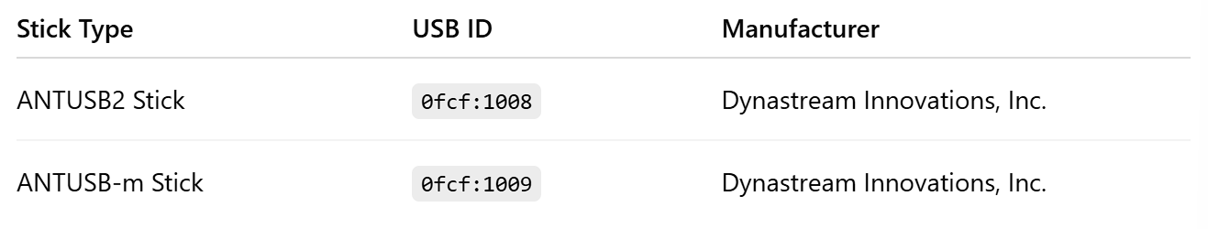

⚠️ **Important:** Do **not mix** different types of USB sticks. Using mixed types causes driver incompatibility, and the application may **fail to initialize** properly.

✅ The script has been **tested and verified with multiple ANTUSB2 sticks**.

❗ There is **no guarantee** that the script will work correctly with multiple ANTUSB-m sticks, due to potential driver and compatibility issues.

💡 The USB drivers tested and compatible with this script are **libusb0** and **libusb1**. You may use tools like **Zadig** to assign the correct driver to each ANT USB device.

To check your USB device type:

* Open Device Manager
* Expand “Universal Serial Bus devices”
* Look for ANT+ USB device and confirm the type

## Check the Python Environment

The script requires a specific Python environment, with the following components:

* **Python 3.8.17**
* **libusb1 3.3.1**
* **openant 1.3.3**
* **pyusb 1.2.1**

⚠️ **Note:** The openant library has been **modified** to support **multiple ANT+ dongle connections**. Therefore, you **must use** the provided environment under the myenv folder to run the script. Run.bat will use the python.exe in the myenv to run the script, or you can manually run gui_script.py under the src folder with the provided myenv.

## Launch the Application

Upon launch, a **GUI application** will appear:

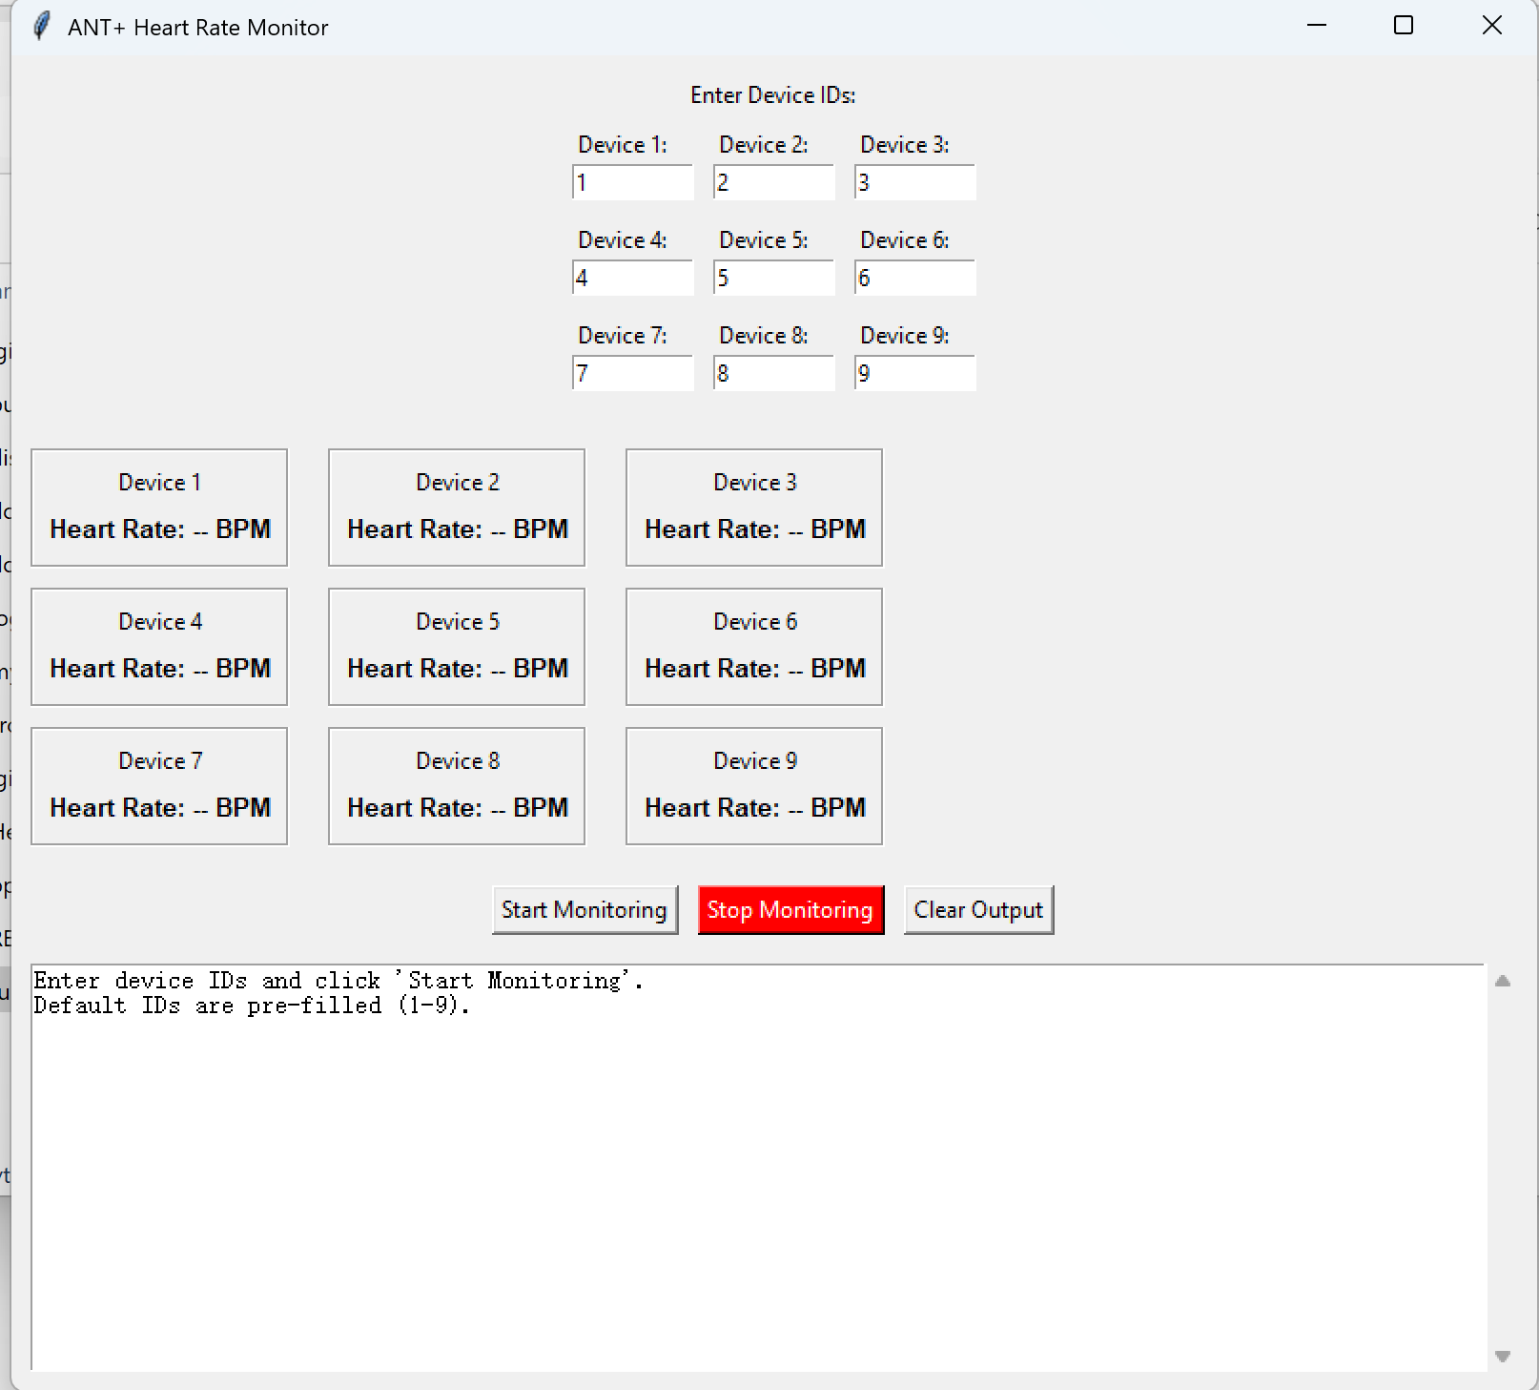

Input the ANT+ ID on your heart rate monitor into the Device X field, and press “**Start Monitoring**” to see the heart rate data.

If everything running successfully, you will see the following:

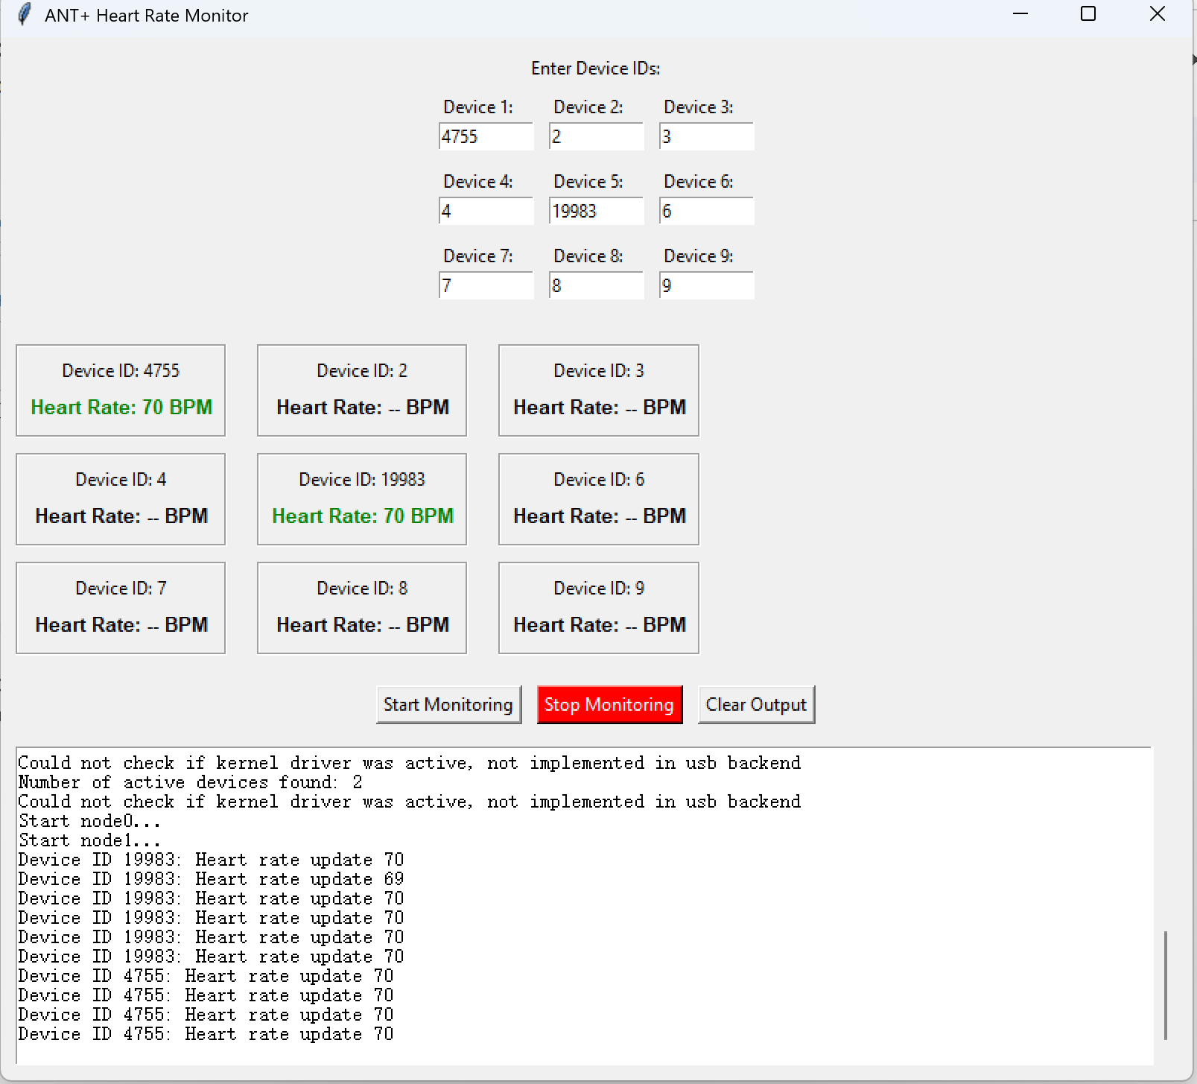

❗ IMPORTANT: Press “**Stop Monitoring**” before you quit. If not, the usb will not be released for other applications to access.

# Known Issue:

## By 06/05/2025:

* How the data will be passed to other applications is not decided yet. Currently the way is to use a MQTT broker. Kindly disable the MQTT configuration in heart_rate_mqtt_broker.py to test ANT+ devices connection.
* 2 ANT sticks are tested. The UI will be changed to 32 devices when 4 ANT sticks are tested.
* Troubleshoot: 1. Unplug the usb sticks 2. Plug it back 3. Rerun the script.